**11.1 Sociology: Theories and Institutions**

Theoretical Approaches

* Provide frameworks for the interactions we observe within the society

1. Functionalism
   1. Focuses on the **function** of each component of society and how these components fit together
      1. Dysfunctions are harmful consequences of people’s actions as they undermine a social system’s equilibrium
      2. E.g. Illness is seen as a **social phenomenon** rather than a physical condition because the sick individual cannot be a productive member of society
   2. Two types of function:
      1. Manifest
         1. **Deliberate** actions that serve to **help** a given system
         2. E.g. annual medical meetings to educate a group of physicians
      2. Latent
         1. **Unexpected**, unintended, or unrecognized **positive** consequences of manifest functions
         2. E.g. stronger interpersonal bonds between physicians
2. Conflict Theory
   1. Focuses on how **power differentials** are created and how these differentials contribute to the maintenance of social order
   2. Claims society is in a state of perpetual **conflict** because of competition for limited resources
   3. Holds that social order is maintained by domination and power, rather than consensus and conformity
3. Symbolic Interactionism
   1. Study of the ways individuals interact through a shared understanding of words, gestures, and other **symbols**
   2. E.g. friendliness codified in waving hand gesture
4. Social Constructionism
   1. Explores the ways in which individuals make decisions to **agree upon a given social reality**
   2. Subject to the processes of **meaning-making** and **collective definition building**
   3. E.g. paper money and coinage do not inherently have significant value; it is only because we as a society imbue them with value that they can be used for trading
5. Rational Choice and Exchange Theory
   1. Individuals will make decisions that maximize potential benefits and minimize potential harm(i.e. considering the **pros and cons**)
   2. Exchange theory applies rational choice theory **within social groups**
   3. Rational choice theory applies to **an individual** independently of social interactions
6. Feminist Theory
   1. Explores the ways in which one’s gender can be subordinated, minimized, or devalued compared to the other

Social Institutions

* Well-defined social structures that dictate certain patterns of behavior or relationships and are accepted as a fundamental part of culture

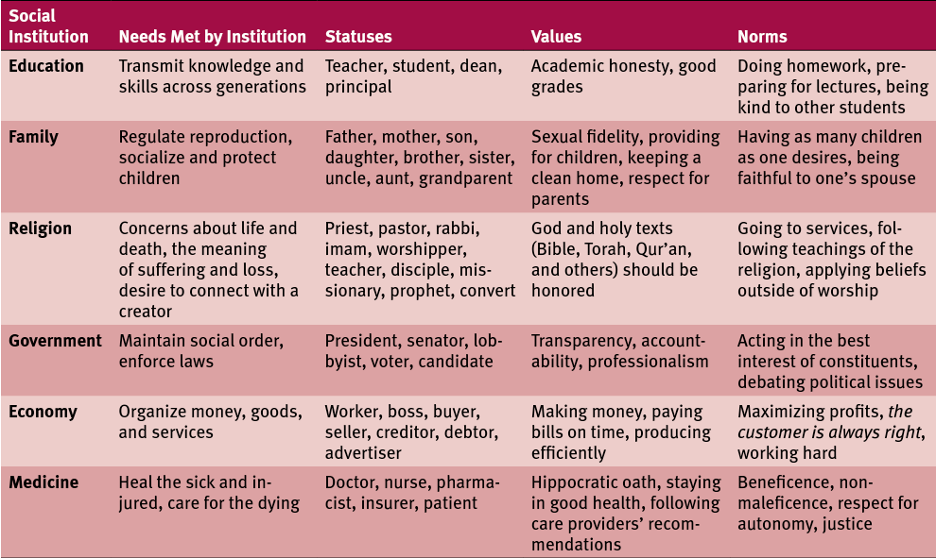

**11.2 Culture**

Material and Symbolic Culture

* Culture lag refers to the idea that material culture changes more quickly than symbolic culture
  + E.g. In American culture, social media (community-oriented) expands faster than symbolic culture (individuality and privacy)

1. Material culture
   1. Includes the physical items one associates with a given group, e.g. artwork, emblems, clothing, jewelry, food, buildings, and tools
2. Symbolic (**non-material**) culture
   1. Includes the **ideas** associated with a cultural group

Language

* Consists of spoken or written symbols combined into a system and governed by rules
* Useful medium to transmit culture

Values, Beliefs, Norms, and Rituals

* Value = what a person deems important in life
* Belief = something a person considers to be true
* Ritual = formalized ceremonial behavior
  + Governed by specific rules, including appropriate behavior and a predetermined order of events
* Norms = societal rules that define the boundaries of acceptable behavior

Evolution and Human Culture

* Evolution both influences and is influenced by culture
  + E.g. humans (who are not lactose intolerant) are the only animals to be able to digest milk after adolescence as well as ingest another animal’s milk
  + This mutation permitting digestion may have arisen out of Northern European cultures, which relied heavily on cattle farming for sustenance

**11.3 Demographics**

* Refer to the statistics of populations and are the mathematical applications of sociology

Common Demographic Categories

1. Ageism
   1. Prejudice or discrimination on the basis of a person’s age
2. Gender
   1. The set of behavioral, cultural, or physiological traits typically associated with a biological sex
3. Race
   1. Social construct based on phenotypic differences between groups of people
4. Ethnicity
   1. Social construct that sorts people by cultural factors e.g. language, nationality, religion, and other factors
   2. Symbolic ethnicity = recognition of an ethnic identity that is only relevant on special occasions and does not specifically impact on everyday life
      1. E.g. Irish-Americans celebrating St. Patrick’s Day
5. Sexual orientation
   1. Defined by one’s sexual interest toward members of the same, opposite, or both sexes
6. Immigration
   1. Movement into a new geographical area
   2. Compared to emigration, which is movement away from a geographical area

Demographic Shifts and Social Change

1. Fertility rate = children per woman per lifetime
2. Birth rate = children per 1000 people per year
3. Mortality rate = deaths per 1000 people per year
4. Migration rate = immigration rate - emigration rate
5. Demographic transition = a model used to represent drops in birth and death rates as a result of industrialization
   1. Malthusian theory
      1. Focuses on how the exponential growth of a population can outpace the growth of the food supply
      2. Can lead to social degradation and disorder, similar to the death phase of bacterial growth
6. Social movements = movements organized to either promote (proactive) or resist (reactive) social change
7. Globalization = process of integrating a global economy with free trade and tapping of foreign labor markets
8. Urbanization = process of dense areas of population creating a pull for migration i.e. creating cities